INDIAN INSTITUTE OF TECHNOLOGY JODHPUR
NH 62 Nagaur Road, Karwar, Jodhpur, Rajasthan

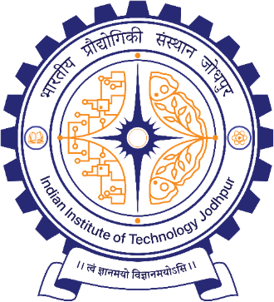
MTech – Data Engineering
TIME SERIES ANALYSIS

Plagiarism Report on
RESERVE BANK of INDIA BALANCE SHEET FORECASTING

Submitted By:
M24DE3011 | Aneerban Chowdhury
M24DE3077 | Sneha Sawla
M24DE3053 | Neha Challa

Executive Summary, Topic 1 to 3
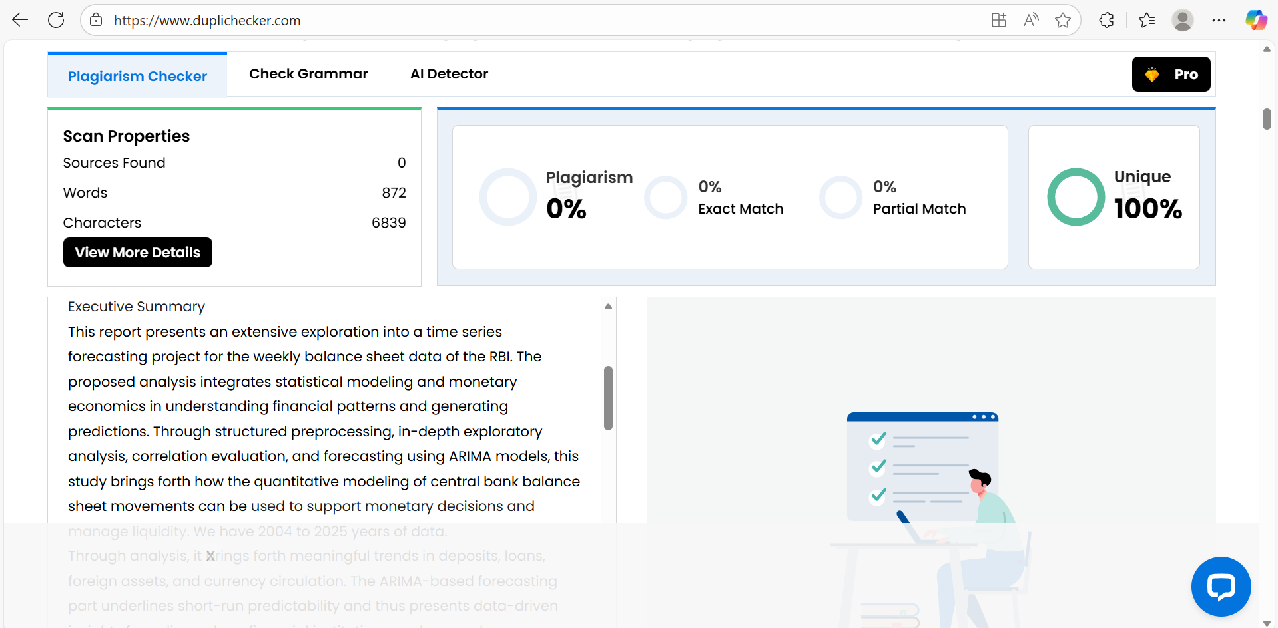

Topic 4 to 5
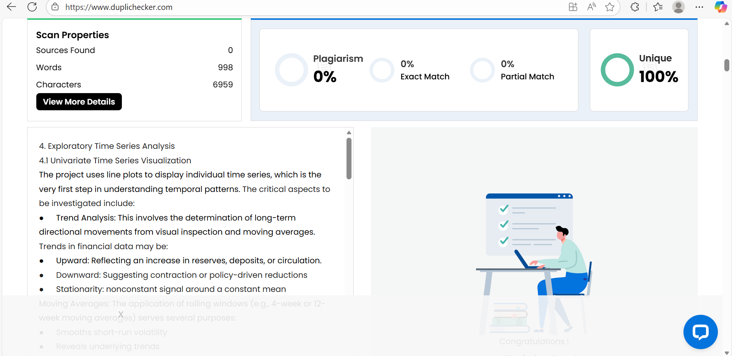

Topic 6 to 9
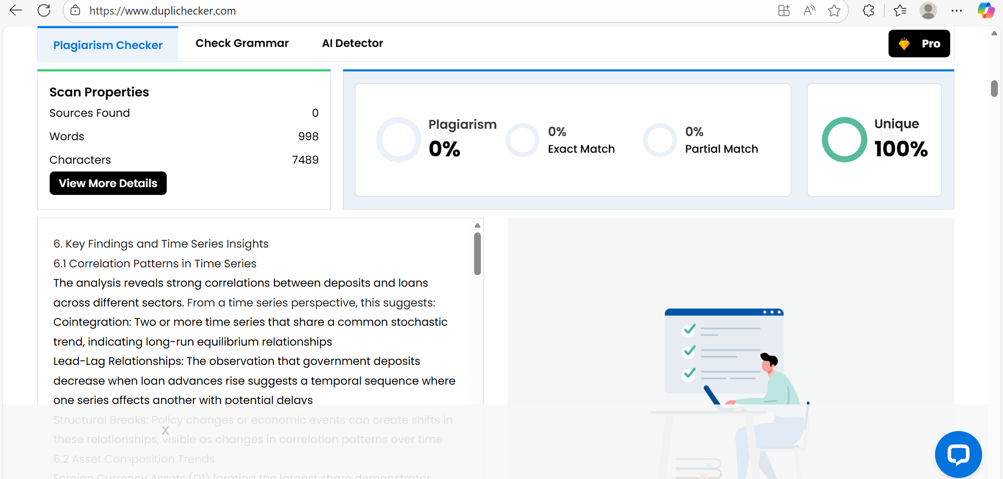

Topic 10, References
